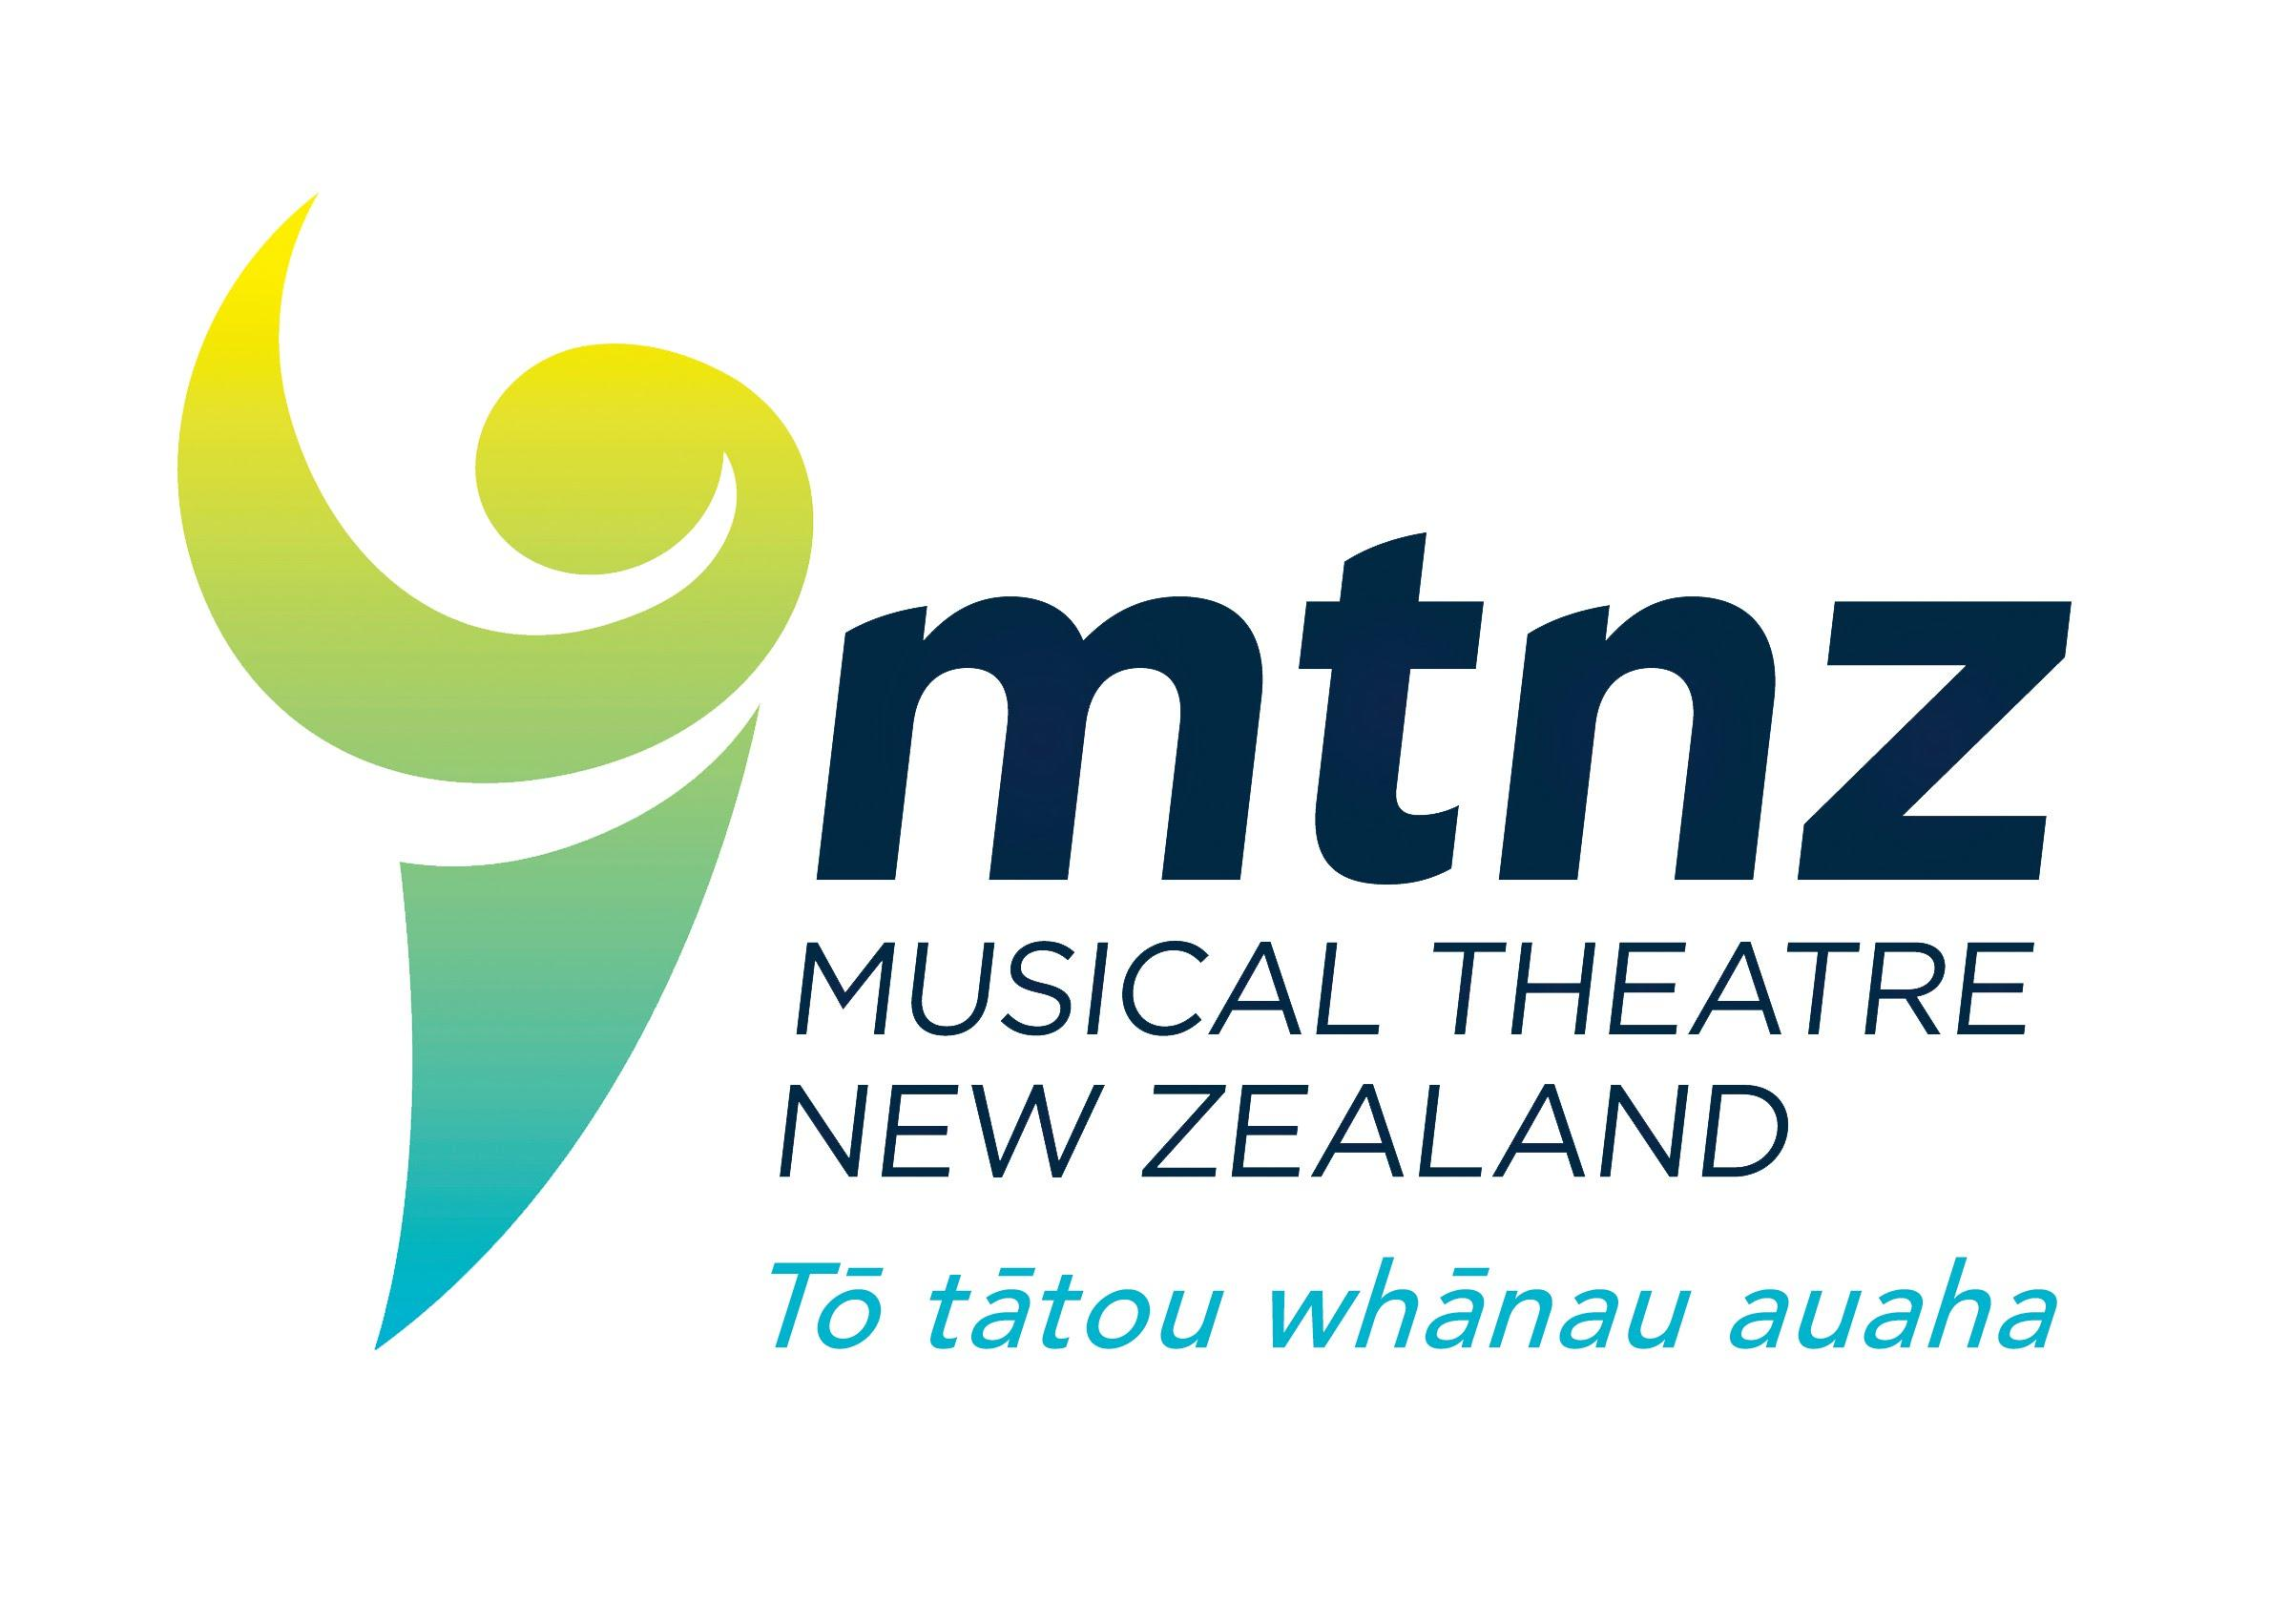

**2024 MTNZ MERIT AWARDS**

Musical Theatre NZ introduced the Merit Awards in 1993 to honour those people in our societies for outstanding achievement and contribution to musical theatre in our communities.

It is currently time to make nominations for the 2024 allocation of merit awards. We invite you to consider the following criteria and complete the attached form to return to the MTNZ office by 31 December, if you have deserving members whom you would like to honour in this way.

The criteria are:

* a current member of the MTNZ Executive cannot be nominated for a Merit Award,
* that the nominee has been an active member of one or more of MTNZ’s member societies for at least 20 years,
* that the nominee has been active in Society productions, either on stage, backstage or front-of-house in a volunteer capacity – i.e. not professionally engaged by the Society,
* that there be a minuted recommendation of the Executive Committee of the nominating Society that such a nomination be made, or a signed letter.
* that only one nomination may be made by a Society in any one year, however, due to certain circumstances the Executive, may, in its sole discretion, consider more than one nomination per society,
* that the nomination be received by the MTNZ office by 31 December for consideration prior to conference,
* that the award nomination be kept confidential and in committee as far as practicable, at the request of the MTNZ Executive committee. The idea is the award is a “surprise” of recognition of service,
* please endeavour to have your nominee at Conference to receive their award. Awards will be presented during the Saturday AGM from 9.45am-11am, Saturday 15th March 2024 - Palmerston North Convention Centre.



**Nomination for**

Musical Theatre New Zealand

***Merit Award 2024***

**Name of Society:**

**Name of Nominee:**

**Years of involvement with the nominating society and/or any other Musical Theatre**

| *Society* | *Years* |
| --- | --- |
|  |  |
|  |  |
|  |  |
|  |  |
|  |  |

Please attach a letter detailing achievements in musical theatre, relevant characteristics and a photo.

Please do so via email office@mtnz.co.nz, or contact Kirsty 02102797798 if email is prohibitive to your nomination submission.

Please outline briefly, four key achievements or characteristics of the nominee that you would like to highlight during the award presentation. These will be read out.



**Signed President/Secretary:**

**Signed other committee member:**

**Contact email and phone number:**

An additional statement in support of this nomination should be attached.

Nominations are to be received by 31 December each year.

Please email signed form and other documents to [office@mtnz.co.nz](mailto:office@mtnz.co.nz)

Further information, please contact Kirsty Skomski, [office@mtnz.co.nz](mailto:office@mtnz.co.nz), 02102797798

Keep a copy for your records.

**Final checklist:**

* Photo and Nomination/endorsement letter are attached.
* Two signatories; President/Secretary and another committee member.
* Bulleted highlights list is complete for the award presentation.
* All documents are labelled appropriately so when they are downloaded it is known what the document is: i.e. Kirsty Skomski Merit Award Photo, or Kirsty Skomski Merit Award Form.
* Applicants not present will have their award presented at a later date - sent to either the relevant Zone Representative, or the Society.